**Ticket price – Analysis and Recommendation**

The Big Mountain resort current ticket price is **$81**. The data set provided covered 330 ski resorts throughout the USA, with 40 features. A random forest model was found to predict the ticket price with the mean absolute error of **$10.59** and standard deviation of **$1.75**. The model revealed only 8, of the 40 features, were most important for ticket price consideration, as seen in red shaded area in plot below

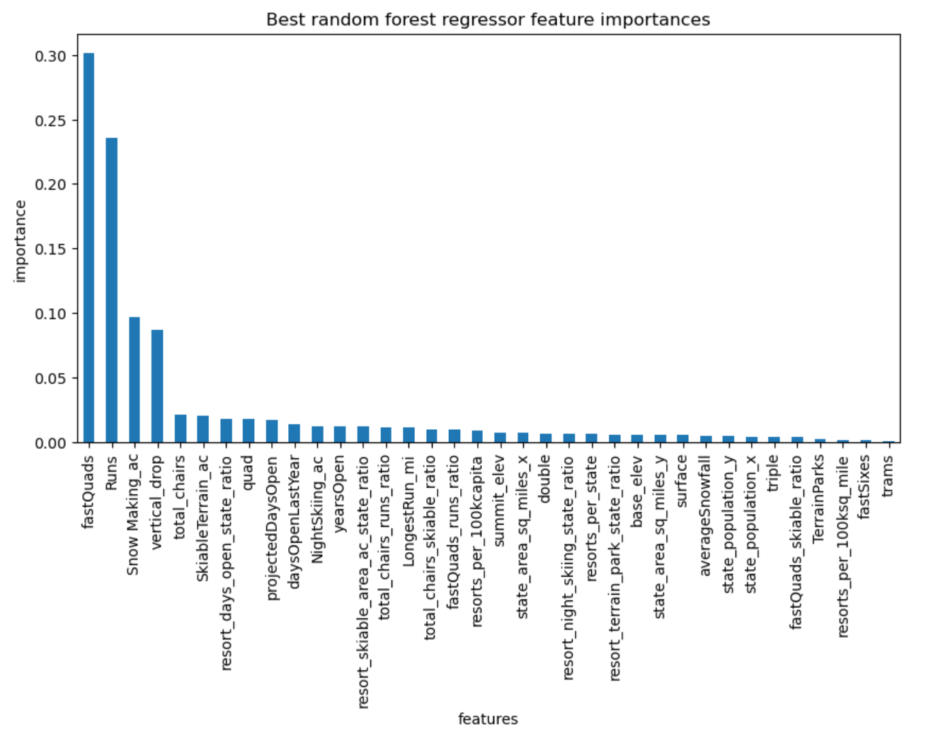



The 8 features, ranked in descending order from most important along with their model coefficients, are:

* vertical_drop 10.767857
* Snow Making_ac 6.290074
* total_chairs 5.794156
* fastQuads 5.745626
* Runs 5.370555
* LongestRun_mi 0.181814
* trams -4.142024
* SkiableTerrain_ac -5.249780

The Big Mountain Resort current pricing when all resorts in the USA are considered is shown in the plot bellow with a dotted red line. The **$81** price is below the median of all prices, but above the distribution mean. The price calculated by the model is **$99.79**.

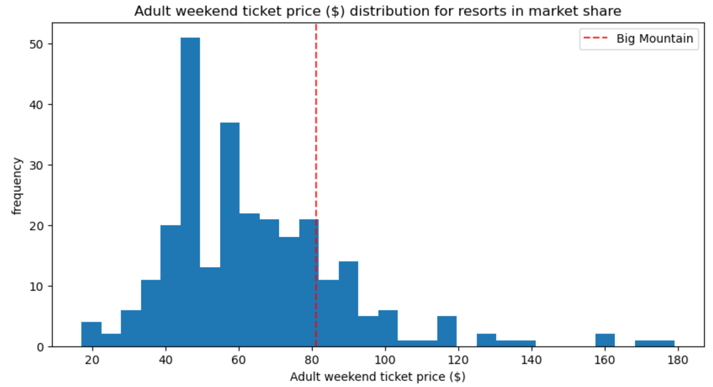

The Big Mountain Resort current pricing when only resorts in the state of Montana are considered is shown in the plot bellow with a dotted red line.

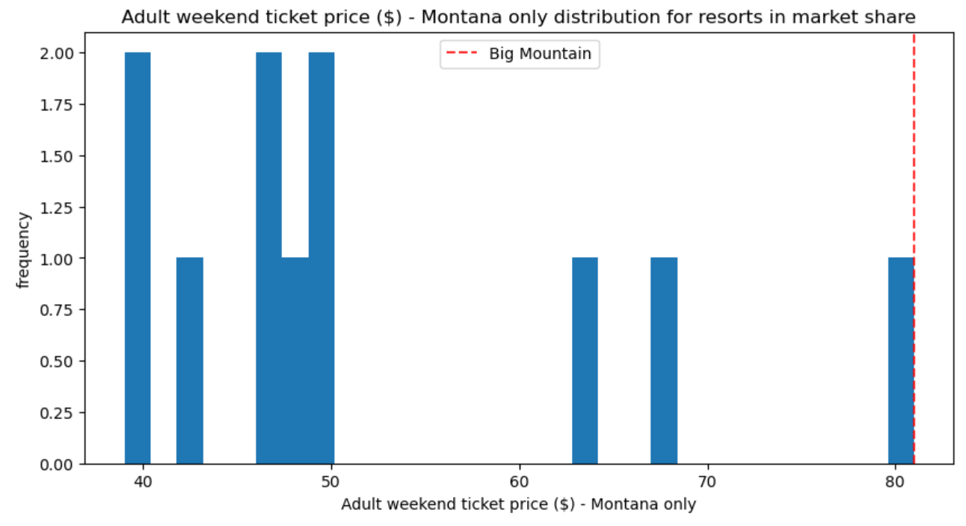

The plot indicates the current price of **$81** is already the highest in the state of Montana. However, the resort is competing against all resorts in USA, therefore the price increase is justified.

I recommend to reduce the modeled predicted price of **$99.79** by the mean absolute error of **$10.59** to establish a price point base from which further incremental price increase could be considered.

Thus, the recommended price is **$89**.

Four scenarios were considered and it was concluded the closure of one run would not affect the adoption the new price ticket, while it will reduce expenses.

I recommend revisiting the performance of the model after two seasons with updated data.